Git and GitHub task 02

1. Install Git
Download from https://git-scm.com/downloads
Check installation: git –version
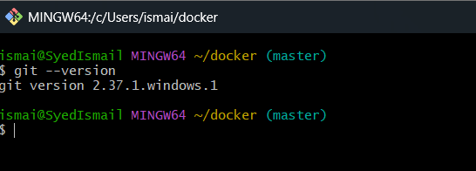

2. Create a repository in GitHub with README.md and .ignore
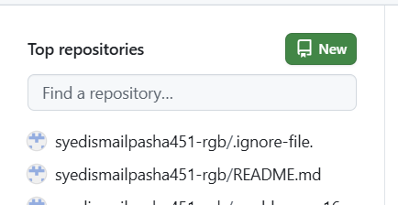

3. Clone the created repository to local
To clone the repository to local
git clone <ssh url from github>

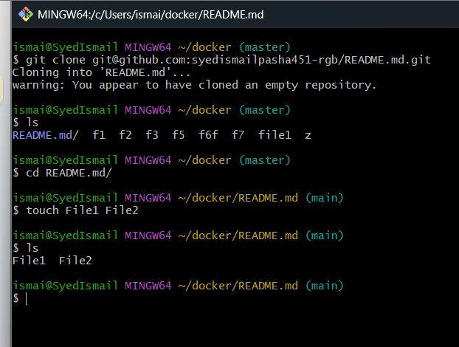

Commit two files and push to central Repository.
4. Create two files in local repository
file1 and file2 are created in local repository
touch file1 file2

5. Commit two files and push to central repository
To add files to central repository, we need to add files to tracking area
git add .
Then commit the files and add commit message
git commit -m “added two files”
Then push the files to central repository
git push -u origin master

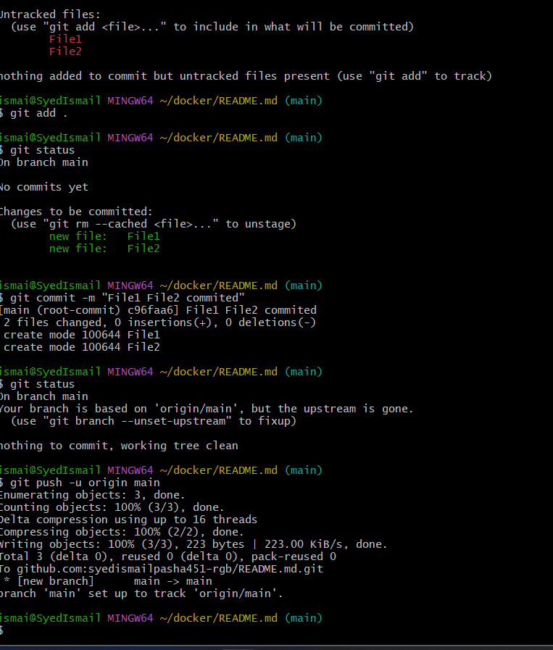

6. Create a branch in local and create a sample file and push to central
To create a branch in local the command is
git checkout -b sample-branch
-b is to create a branch and switch to it
sample-branch is local branch name
To add a sample file to it use
touch sample-file ---- File will be created named sample-file
Then add and commit the sample-file
git add .
git commit -m “added sample file”
Then push to central repository in git hub
git push -u origin sample-branch

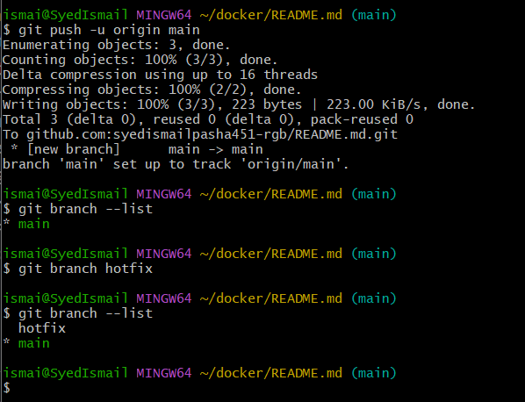

7. Steps: to create new branch from git hub go to git hub and create branch
# to clone the selected branch<git clone –-branch “feature” ssh id
